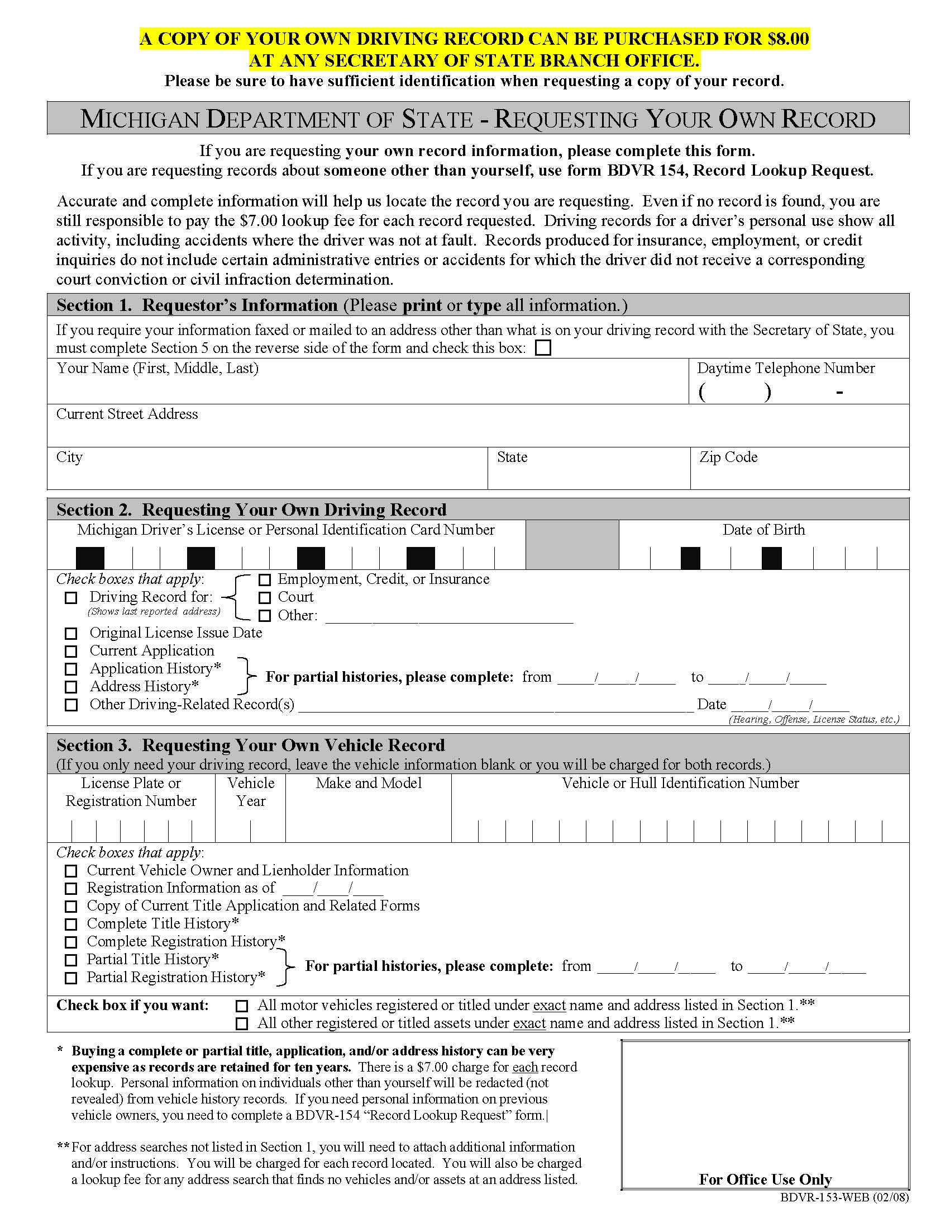
Lucila Hernandez 877 886 5099
P. O. Box 184
Oyster Bay NY 11771
10/31/1944
1
X

X Legal Matter
X

Order No. 01-24322 - 007
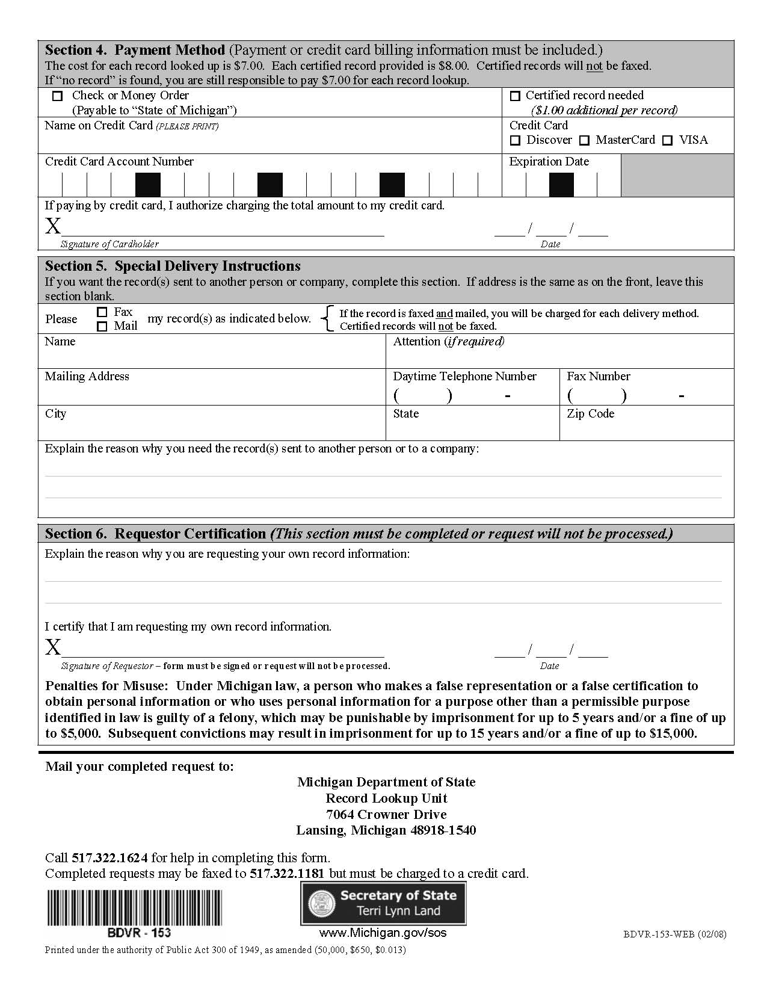Order No. 01-24322 - 007
X
Axiom Requisition Copy Service Vicki Lintemuth
2869 Jolly Rd 517 886 5099 517 886 4116
Okemos MI 48864
Litigation

